DATA SCIENCE MINOR PROJECT REPORT

CONTENTS OF THE REPORT
- Cover page
- Declaration
- Certificate
- Acknowledgement
- Table of Content

1. Introduction
2. Source of dataset
3. Dataset Preprocessing
4. Analysis on dataset (for each objective)
- General Description
- Specific Requirements
- Analysis results
- Visualization
5. Conclusion
6. Future scope
7. References

Other Conventions

- Please note the case of letters in the cover page: The 3rd line is 16 pt bold and other lines are 12 pt. The page is centred. Department and Institute names are bold.
- All the matter contained in the report should be typed in MS word (1.5 spacing) Times New Roman, 12 pt or equivalent with other software.
- Figures and tables may be inserted in the text as they appear or may be appended in order.
- Table of Content shall be in well hyperlinked
- List of figures and tables shall be maintained with captions in MS word.
- List of references shall be appended at the end.
- References shall be in IEEE format
- Total Number of pages with A4 size paper shall be minimum 30 pages and maximum 80 pages.
- Hard copy of report must be available with each student on the day of evaluation.
- In addition to Hard copy of reports e-copy shall also be submitted. An e-copy of the report shall be submitted by the student to respective teacher on their emails.

INTRODUCTION TO DATA MANAGEMENT
PROJECT REPORT
(Project Semester January-April 2025)

GenZ Carrier Prefrence Analysis

Submitted by
Md Farhan Ahmad
Registration No: 12317236
Section: k23GS
Course Code: INT217

Under the Guidance of

Baljinder Kaur (UID:27952)

Discipline of CSE/IT

Lovely School of Computer Science

Lovely Professional University, Phagwara

CERTIFICATE

This is to certify that Md Farhan Ahmad bearing Registration no. 12317236 has completed INT217 project titled, “GenZ Carrier Preference Analysis ” under my guidance and supervision. To the best of my knowledge, the present work is the result of his/her original development, effort and study.

Baljinder Kaur
Assistant Professor
School of Computer Science
Lovely Professional University
Phagwara, Punjab.

Date: 13.04.2025

DECLARATION

I, Md Farhan Ahmad, student of Computer Science under CSE/IT Discipline at, Lovely Professional University, Punjab, hereby declare that all the information furnished in this project report is based on my own intensive work and is genuine.

Date: 13.04.2025 Signature
Registration No. 12317236 Md Farhan Ahmad

ACKNOWLEDGEMENT :
I would like to express my sincere gratitude to my project guide, Baljinder Kaur, for their
invaluable guidance and support throughout the course of this project. I would also like to
thank the Department of Computer Science and Lovely Professional University for
providing the necessary resources and a platform to work on this project.

1. Introduction

This project analyzes the preferences, motivations, and expectations of Generation Z (Gen Z) individuals in India concerning work environments, learning methods, and employer attributes. The goal is to provide insights that can help organizations align their practices with Gen Z values.

2. Source of Dataset

The dataset titled "genz analysis 2.xlsx" includes responses collected via a survey from 2,634 participants in India. It comprises data on work models, employer preferences, learning styles, career interests, and more.

3. Dataset Preprocessing

Removed unnecessary whitespaces from column names.

Filtered relevant columns such as Gender, Work model, Preferred Employers, Learning Model, and Working Setup.

Addressed duplicate columns like “Mission is not clearly defined”.

Parsed and structured values into categories for meaningful analysis.

4. Analysis on Dataset (for each objective)

General Description:

Total Records: 2,634

Gender Breakdown: 64% Male, 36% Female

Specific Requirements & Analysis Results:

A. Preferred Employers

97% of respondents prefer employers that offer Learning and Rewards.

Only 3% are okay with employers lacking growth/learning incentives.

B. Work Model Preferences

Most preferred: Remote + Travel (27%), Hybrid < 15 days (25%)

Least preferred: Remote only (5%)

C. Learning Models

Instructor-led programs (31%) and Self-paced learning (24%) are top choices.

Observation and Trial-and-error methods are also valued.

D. Working Setup

Majority prefer working in Small (31%) or Very Small teams (30%).

Individual contribution (16%) and Big teams (13%) are less favored.

Visualization:

If you'd like, I can generate charts for:

Gender-wise breakdown of preferences

Pie charts for work model and learning model preferences

Bar charts for employer and working setup choices

5. Conclusion

Gen Z in India values growth opportunities, flexible work models, and collaborative team environments. They are inclined towards structured learning and working in smaller, more agile teams. Employers focusing on rewards, learning, and flexibility are more likely to attract and retain this generation.

6. Future Scope

Expand the analysis to include qualitative insights (e.g., open-ended responses).

Compare results across countries or over time.

Use clustering techniques to identify personas within Gen Z.

7. References

Dataset: genz analysis 2.xlsx

Source: Internal survey, 2022

Dashboard Picture :
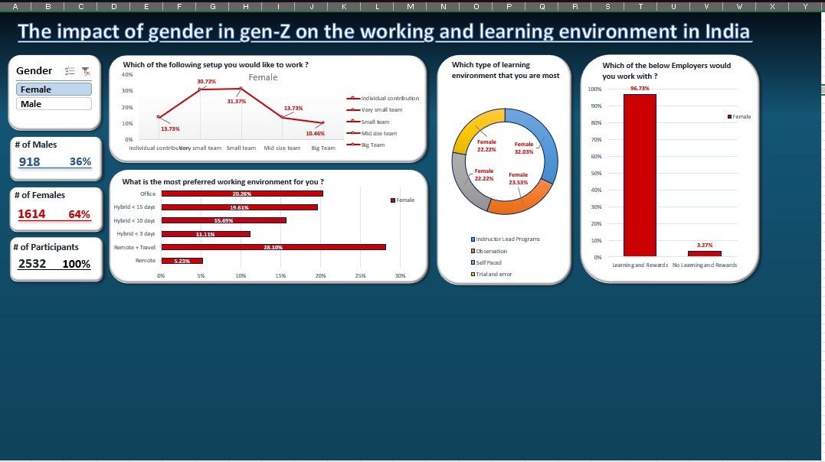

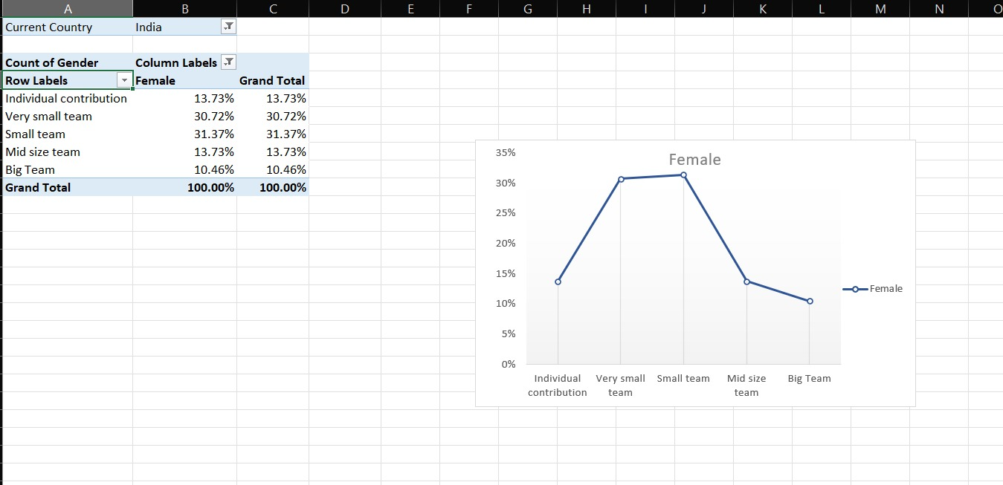

WorkSetup Picture :

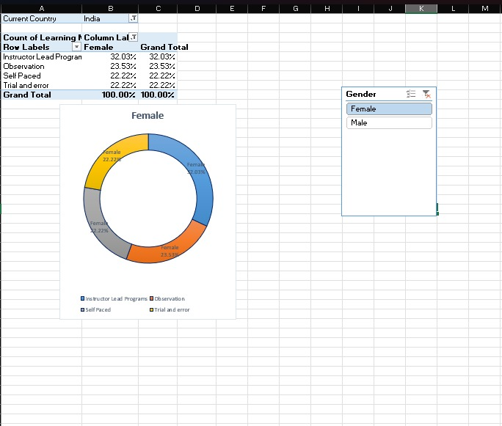

Learn Model Picture :
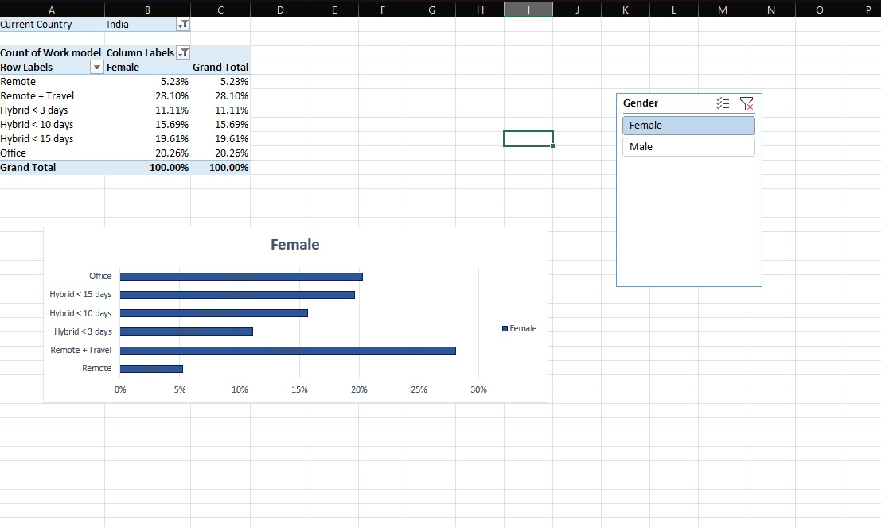

Work Model Picture :
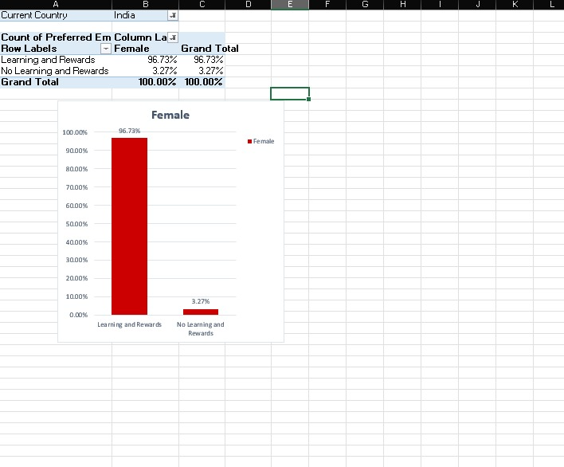
EmployerType Picture :

Linkdin Post :

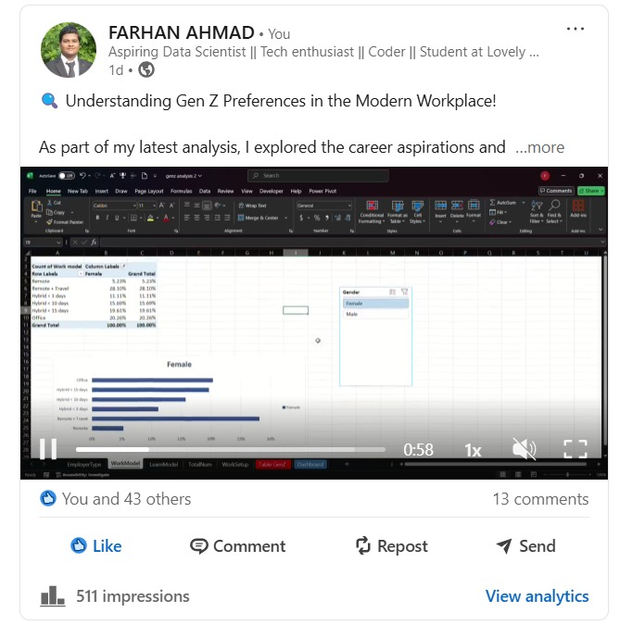

Linkdin Post Link :

https://www.linkedin.com/posts/farhan-ahmad-69772128a_dataanalysis-genz-futureofwork-activity-7316527931290263552-LgcO?utm_source=share&utm_medium=member_desktop&rcm=ACoAAEY64JMBMvApc1pCTlZOpjcIL6kN5x-RsvQ

